Iqra University

Assignment: Assignment 4(User Instruction Manual)

Subject: Software Engineering

Instructor: Dr Mansoor Ebrahim

Semester Spring 2022

Program: BS (CS)

**Group Members:**

|  |  |  |
| --- | --- | --- |
| **Name** | **Student ID** |  |
| **Syed Rafay Hussain** | **51381** |  |
| **Osama Abdullah** | **50442** |  |
| **Muhammad Saaim** | **50441** |  |

Github: https://github.com/saaimirfan/Resturant-Managment-System_SE_Project

Video <https://drive.google.com/drive/folders/1zDCsELXCV_b2xo8bdaWzr39vz_HgZjDU?usp=sharing>

SE-Project: Restaurant Management System

TABLE OF CONTENTS

Login Page-------------------------------------------------------------------------------------3

Admin Page-----------------------------------------------------------------------------------4

Edit Price--------------------------------------------------------------------------------------5

Enable /Disable Product---------------------------------------------------------------------6

Add \Delete Users----------------------------------------------------------------------------7

Welcome--------------------------------------------------------------------------------------8

Main Menu------------------------------------------------------------------------------------9

Sub-Menu------------------------------------------------------------------------------------11

Invoice Page---------------------------------------------------------------------------------13

Login Page

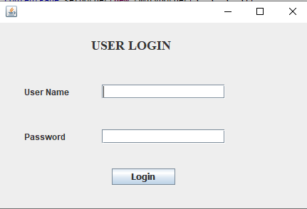

Instructions:

For Admin: By using Default Admin credentials the admin can enter an admin page where he can

1. Enable Disable products
2. Register or Delete employees credentials
3. Edit the price of products

For Employees: Enter a valid user name and password to proceed to employee interface

Default Admin Credentials:

Username: admin

Password: admin

Admin Page:

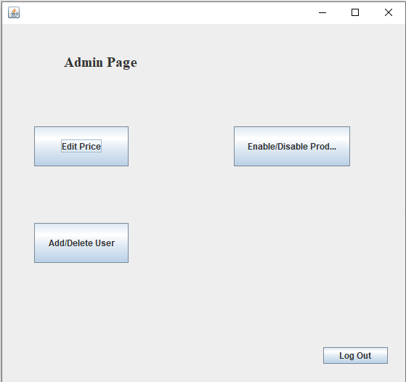

Instruction:

1. When the admin credentials are enters an admin page will appear where the admin can navigate to different admin controls
2. Just click on the desired button to continue or press “Logout” To return to Login Page

Edit Price:

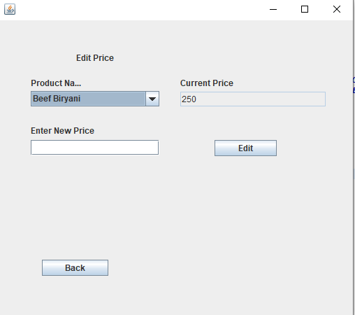

Instruction:

Admin can edit prices of different products from the menu by clicking on the product name from the drop down menu

The system will give the current value set to the product and if a change of value is desired the user can enter a new value to “Enter New Price” textfeild” and press “Edit” the new value will be updated on the menu.

Enable /Disable Product:

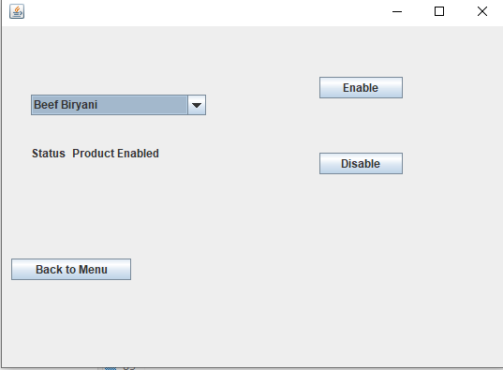

Instruction:

If the admin desires not to sell the product he can disable the product by simple selecting the desired product from drop down menu and press the “disable “ the product will be disabled from the menu.

If the admin desires enable the previously disabled product he can Enable the product by simply selecting the desired product from drop down menu and press the “Enable “ the product will be enabled from the menu.

Add \Delete Users:

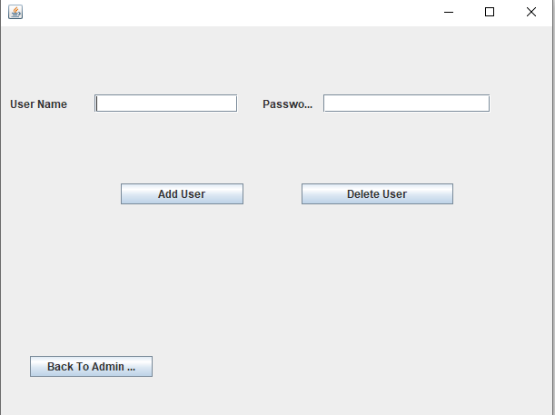

Instructions:

The Admin can Enter New Employees by giving entering User name and password on the “User Name” and “Password” Text field and press add user button.

If Admin desired to erase the credential of the existing user he can just enter the Username given to the Employee and press “Delete User”.

Welcome:

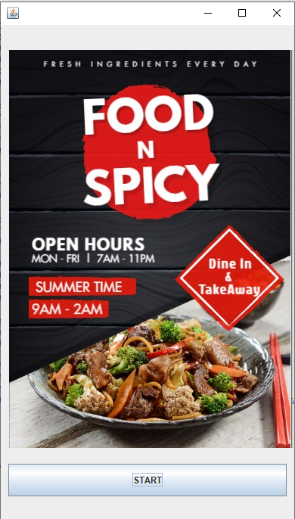

Instruction:

After employee enters correct user name and password this page will appear to proceed to the menu press Start.

Main Menu:

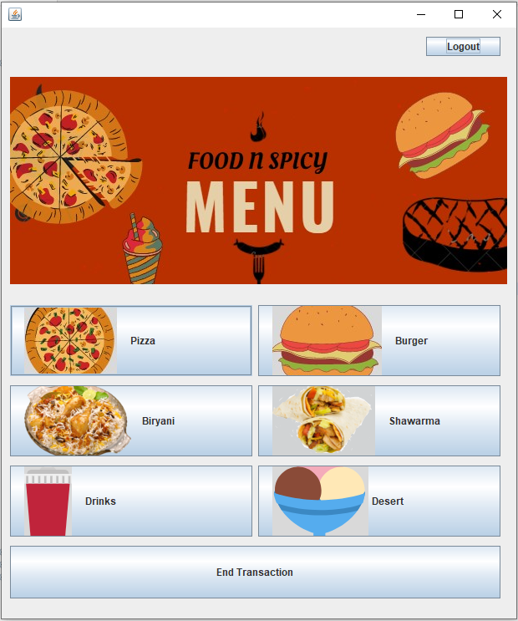

Instruction:

Employees can select the desired menu categories if the category is selected the user will be directed to a sub-menu.

If the user wants to Logout from the system he logout by just a press of the “Logout” Button

Sub-Menu:

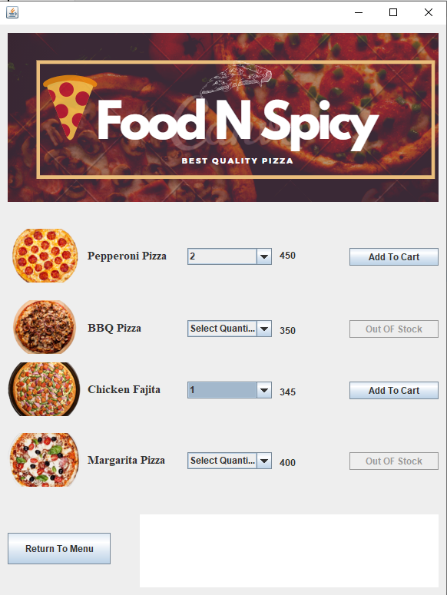

Instruction:

After the required category is Selected the system will direct the user to a sub menu where he can select the items the customer has ordered add the item to invoice.

1. Select the Quantity of required product and press “Add to Cart”.
2. If the product is disabled by the admin the Button will display “Out OF Stock” and the button will be disabled.

After the Selection is made from Any Sub Menu User can Press the “Return to Menu”

Which will take the user back to Main Menu.

Invoice Page:

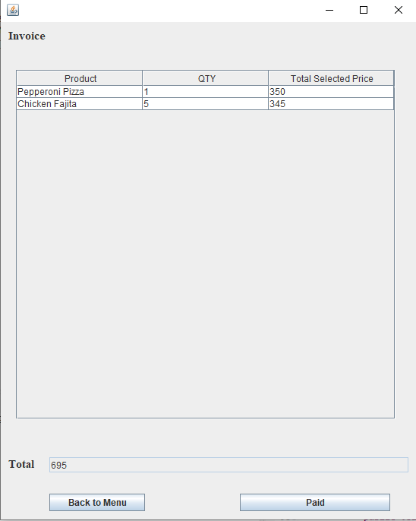

Instructions:

1. When the customers wants to check out the employee can press the “End Transaction “button from the Main Menu which will take the employee to the final page of this system which is “Invoice”.
2. This Page will display the all the product the customer has ordered with a total amount.
3. When the customer pays the Employee the Employee will press Paid which will clear the invoice details of the previous customer and will reset the system and will return the employee to Main Menu.